WQD7010
Network & Security

Tutorial 1
Introduction to Network Security & Symmetric Encryption (10 Marks)

Problems:

- A desktop publishing system is utilized for creating documents across different organizations.

- Identify a publication type where the utmost priority is the confidentiality of data maintained within the system. (0.5)
- Mention a publication type where ensuring the integrity of data is the primary concern. (0.5)
- Highlight a scenario in which the most crucial aspect is the system's availability for document production. (0.5)
Solution:

a. The system will have to assure confidentiality if it is being used to publish corporate proprietary material.
b. The system will have to assure integrity if it is being used to laws or regulations.
c. The system will have to assure availability if it is being used to publish a daily paper.

- You are a senior IT executive at your department responsible for the DES encryption key management. From the random key generator, you are given the secret key (E0E0E0E0F1F1F1F1)hex to encrypt a critical message.

- What is is the output of the key after it is applied with the parity bit drop process shown in Figure 1? At this point, determine if it is a strong, weak, or semi-weak key. Provide a detailed explanation for your assessment. (1.25)
- Using the key-permutation compression 2 from Figure 2, re-evaluate whether this is a strong, weak or semi-weak key. Justify your answer thoroughly and explain the implications of using this key for encrypting the critical message. (1.25)

Figure 1: Parity bit drop

Figure 2: Key-Permutation Compression 2

Solution:

i. After applying the parity bit drop process from Figure 1, the output key is: (E0E0E0F1F1F1)hex
To determine the key strength:
- The key has alternating 0's and 1's in the first and second halves (E0E0E0 and F1F1F1), making it a semi-weak key.
- Semi-weak keys lead to a small number of effective keys during the DES encryption rounds, reducing the key space and making the encryption more susceptible to brute-force attacks.
Therefore, at this point, the key is classified as a semi-weak key due to its alternating pattern, which weakens the encryption strength.

ii. Using the key-permutation compression 2 from Figure 2, the output key is: (3B3B3B3B7D7D7D7D)hex
Re-evaluating the key strength:
- The permuted key still exhibits an alternating pattern of 3B and 7D in the first and second halves.
- This maintains the characteristics of a semi-weak key, as the effective key space remains reduced during the DES encryption rounds.
- Using a semi-weak key for encrypting a critical message is not recommended, as it increases the risk of the encryption being compromised through cryptanalytic attacks.
- A strong key should have a random distribution of bits without any discernible patterns to maximize the effective key space and resist potential attacks.
In conclusion, even after applying the key-permutation compression 2, the key remains a semi-weak key due to its alternating pattern. Using this key for encrypting a critical message is inadvisable, as it weakens the overall security of the encryption. It is recommended to generate a new, strong key with a random distribution of bits to ensure the confidentiality and integrity of the critical message.

- Let M be the plaintext message M = MALAYSIA and the private key, K = ISSOGOOD (this question is lenghthy and you can used tools or programming language to solve this, but show some work in your solutions how you obtain the output)

- Convert this plaintext and key message to Hexadecimal representation using the ASCII table. (0.25)
- Convert the Hexadecimal representation to binary number. (0.25)
- Represent your plaintext binary number as a form of a block, using the DES encryption technique (2 equal blocks). (0.25)
- Using the initial permutation (table is provided below), please provide your plaintext output. (0.25)
- Using the expansion P-box (table is provided below), show the plaintext output of this process. (0.25)
- For the key: Using the key permutation table (provided below), show the output of this conversion process. (0.25)
- Using the appropriate steps of DES operation, what is the final output of the key for round 1 (hint: you have to use the circular left shift and permutation compression (PC) table provided below). (0.5)
- For round 1, please provide your output for the XOR operation of plaintext and the key, according to the DES operation. (0.5)
- Based on the output of 4(h), explain the next process using the S-box table, and show the output from this operation. (0.25)
- Based on the output of 4(i), explain the next process using a straight permutation table, and show the output from this operation. (0.25)

Solution:

1. PT: MALAYSIA

a) (4d 41 4c 41 59 53 49 41)hex

b) PT = 0100 1101 0100 0001 0100 1100 0100 0001 0101 1001 0101 0011 0100 1001 0100
0001

c)
L0 = 11111111 00110000 00000101 11111011
R0 = 00000000 00000000 01010101 00100000

d) IP(M) = 11111111 00110000 00000101 11111011 00000000 00000000 01010101
00100000

e)
Ln = Rn-1
Rn = Ln-1 + f(Rn-1,Kn)

L1 = R0 = 00000000 00000000 01010101 00100000 R1 = L0 + f(R0, K1)

Expand R0 to 48 bits using Expansion P-Box

E(R0) = 000000 000000 000000 000000 001010 101010 100100 000000

Key:

K: ISSOGOOD

a) K = (49 53 53 4F 47 4F 4F 44)hex

b) K = 01001001 01010011 01010011 01001111 01000111 01001111 01001111 01000100

f) KP(K) = 00000000 11111111 00000000 00000110 11101111 10000110 10010110

- Rearrange in 7-bits per group

0000000 0111111 1100000 0000000 0110111 0111110 0001101 0010110

Rearrange left and right:
KL0 = 0000000 0111111 1100000 0000000
KR0 = 0110111 0111110 0001101 0010110

Using left shift table
KL1 = 0000000 1111111 1000000 0000000
KR0 = 1101110 1111100 0011010 0101100

Combine the left and right key:

KL1KR0 = 0000000 1111111 1000000 0000000 1101110 1111100 0011010 0101100

Using key permutation compression table:

PC (KL1KR0) = 10100000 10010010 01000010 00010011 11110010 11100111

- XOR operation of E(R0) and PC (KL1KR0)

E(R0) = 00000000 00000000 00000000 00101010 10101001 00000000
PC(KL1KR0)= 10100000 10010010 01000010 00010011 11110010 11100111

E(R0) XOR PC(KL1KR0) = 10100000 10010010 01000010 00111001 01011011
11100111

- Using S-Box

First we have to rearrange in 6-bits per group:

E(R0) XOR PC(KL1KR0) = 101000 001001 001001 000010 001110 010101 101111 100111

Applying sbox: 1101 1111 0011 1101 0110 1101 0111 0111

- Using straight permutation table:

f = 11010110 10011110 11111100 11111110

R1 = L0 XOR f

  - 11111111 00110000 00000101 11111011 XOR
  - 11010110 10011110 11111100 11111110
  - 00101001 10101110 11111001 00000101

R1 = 00101001 10101110 11111001 00000101

- Consider a scenario where an attacker intercepts a ciphertext C, which is the result of encrypting a fund transfer message M using a stream cipher with key K. The attacker knows that bytes 37-42 of the message contain the amount to be transferred, initially set to 500 MYR. The attacker wants to modify the ciphertext to change the transfer amount to 500,000 MYR without knowing the entire key K.

- Explain how the attacker can modify the ciphertext C to create a new ciphertext C1 that decrypts to a message with the desired transfer amount of 500,000 MYR. (0.5)
- Provide a mathematical proof to show that the recipient will decrypt the modified ciphertext C1 to obtain the new transfer amount of 500,000 MYR. (0.5)
- Discuss how this scenario demonstrates the failure of stream ciphers in protecting message integrity.(0.5)

Solution:

i) The attacker can modify the ciphertext C by following these steps:

Obtain the corresponding ciphertext C for the original message M.
XOR the original transfer amount (500) with the desired transfer amount (500,000) to obtain the XOR difference: (500 XOR 500,000).
XOR the ciphertext C with the XOR difference to create the modified ciphertext C1: C1 = C XOR (500 XOR 500,000).

ii) Mathematical proof:
Given:

C = 500 XOR K (original ciphertext)
C1 = C XOR (500 XOR 500,000) (modified ciphertext)
Proof:
C1 = (500 XOR K) XOR (500 XOR 500,000)
= 500 XOR 500 XOR K XOR 500,000 (associative property of XOR)
= 0 XOR K XOR 500,000 (XORing a number with itself results in 0)
= K XOR 500,000

At the recipient's end, decrypting C1 with the key K:
C1 XOR K = (K XOR 500,000) XOR K
= 500,000 XOR 0 (XORing a number with itself results in 0)
= 500,000

Therefore, the recipient will decrypt the modified ciphertext C1 to obtain the new transfer amount of 500,000 MYR.

iii) This scenario demonstrates the failure of stream ciphers in protecting message integrity because:

  - Stream ciphers operate by XORing the plaintext with a key stream, which makes them vulnerable to targeted modifications.
  - If an attacker knows the structure of the message and can obtain the ciphertext, they can make meaningful changes to the plaintext without knowing the entire key.
  - The recipient has no way to detect that the ciphertext has been modified, as the decryption process will produce a valid-looking plaintext with the attacker's desired changes.
  - Stream ciphers do not provide built-in integrity protection mechanisms, allowing attackers to alter the ciphertext and correspond

- Using the simplified RC4 Algorithm of 8 bytes (rather than the full 256 bytes), find the final state of the S-Array, Keystream, and Ciphertext for the following inputs:

Initial S-Array, [S0 S1 S2 S3 S4 S5 S6 S7] = [7 2 5 1 0 3 6 4]

Key, K = [2 0 1]

Plaintext, PT = [5 3 1 6]

Hints:

- Perform the initial permutation of the S-Array using the given Key.
- For the simplified stream generation, use this pseudocode (only up to the PT length):
/* Initialization */ set i and j = 0
for i = i + 1 to length of PT
j = j + S[i] mod 8
swap S[i], S[j]
t = S[i] + S[j] mod 8
Keystream = S[t]
end for

- To obtain the Ciphertext, perform a bitwise XOR operation between the Plaintext and the generated Keystream.

Your task is to:

- Show the state of the S-Array after the initial permutation. (0.25)
- Generate the Keystream using the simplified stream generation process. (0.25)
- Calculate the Ciphertext by XORing the Plaintext with the Keystream. (0.5)

Provide the final state of the S-Array, the Keystream, and the Ciphertext as your answer.

Solution:

Step 1: Initial permutation of the S-Array using the Key.
i | j | K[i] | S[i] | S[j] | Swap S[i] and S[j] | S-Array after swap
0 | 0 | 2 | 7 | 7 | [2, 7, 5, 1, 0, 3, 6, 4] | [2, 7, 5, 1, 0, 3, 6, 4]
1 | 2 | 0 | 7 | 5 | [2, 5, 7, 1, 0, 3, 6, 4] | [2, 5, 7, 1, 0, 3, 6, 4]
2 | 7 | 1 | 7 | 4 | [2, 5, 4, 1, 0, 3, 6, 7] | [2, 5, 4, 1, 0, 3, 6, 7]
After the initial permutation, the S-Array is: [2, 5, 4, 1, 0, 3, 6, 7]

Step 2: Generate the Keystream using the simplified stream generation process.
i | j | S[i] | S[j] | Swap S[i] and S[j] | t = S[i] + S[j] mod 8 | Keystream[i] = S[t]
1 | 0 | 5 | 2 | [2, 2, 4, 1, 0, 3, 6, 7] | (2 + 2) % 8 = 4 | 0
2 | 2 | 4 | 4 | [2, 2, 4, 1, 0, 3, 6, 7] | (4 + 4) % 8 = 0 | 2
3 | 6 | 1 | 6 | [2, 2, 4, 6, 0, 3, 1, 7] | (6 + 1) % 8 = 7 | 7
4 | 4 | 0 | 0 | [0, 2, 4, 6, 2, 3, 1, 7] | (2 + 0) % 8 = 2 | 4
The generated Keystream is: [0, 2, 7, 4]

Step 3: Calculate the Ciphertext by XORing the Plaintext with the Keystream.
i | Plaintext[i] | Keystream[i] | Ciphertext[i] = Plaintext[i] ⊕ Keystream[i]
1 | 5 | 0 | 5 ⊕ 0 = 5
2 | 3 | 2 | 3 ⊕ 2 = 1
3 | 1 | 7 | 1 ⊕ 7 = 6
4 | 6 | 4 | 6 ⊕ 4 = 2

The calculated Ciphertext is: [5, 1, 6, 2]
Final Results:
- S-Array after initial permutation: [2, 5, 4, 1, 0, 3, 6, 7]
- Keystream: [0, 2, 7, 4]
- Ciphertext: [5, 1, 6, 2]

- Would it be possible to execute encryption functions in parallel on CBC mode with multiple blocks of messages? How about Decryption? (0.25)

Solution:

In CBC decryption, the input blocks for the inverse cipher function (i.e., the ciphertext blocks) are immediately available, so multiple inverse cipher operations can be performed in parallel.
In CBC encryption, however, the input block to each forward cipher operation (except the first) depends on the result of the previous forward cipher operation, so the forward cipher operations cannot be performed in parallel.

- How far does the error propagate if a bit error occurs in the transmission of a ciphertext character in 8-bit CFB mode? (0.25)
Nine plaintext characters are affected. The plaintext character corresponding to the ciphertext character is obviously altered. In addition, the altered ciphertext character enters the shift register and is not removed until the next eight characters are processed.

Appendix:

ASCII Table

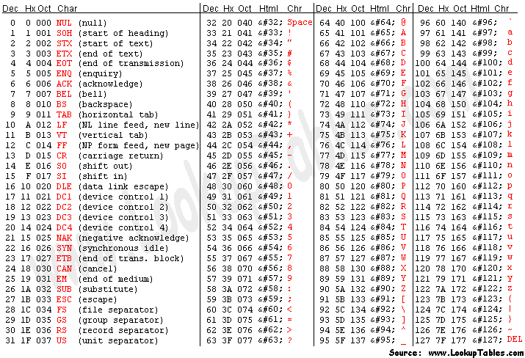

Initial Permutation

Expansion P-box

Key Permutation Table

Key Permutation-Compression Table

S-Box Table

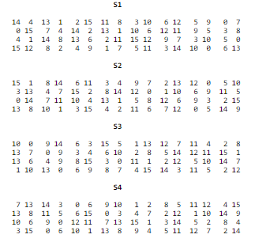

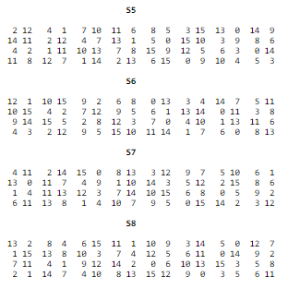

Straight Permutation Table

